|  |  |
| --- | --- |
| **Ex.No:6.B** | **Selection Sort** |
|  |

***Aim:***

To develop a python program to perform sorting in a list using selection sort algorithm.

***Algorithm:***

|  |  |
| --- | --- |
| **Step 1:** | Start Process |
| **Step 2:** | Get a list of numbers from user and store id alist. |
| **Step 3:** | Print “Unsorted list” as alist |
| **Step 4:** | Assign i as zero |
| **Step 5:** | Assign minimum as i value |
| **Step 6:** | Assign j as i+1 |
| **Step 7:** | Compare alist of j position with alist of minimum position |
| **Step 8:** | If alist of j position is less than alist of minimum position then assign j value to minimum |
| **Step 9:** | Else check j with length of list |
| **Step 10:** | If j is reached length of alist goto Step 12 |
| **Step 11:** | Else increment j and goto Step 7 |
| **Step 12:** | If minimum is not equals to i then swap the number’s in the positions minimum and i and goto Step 14 |
| **Step 13:** | Else do nothing and goto Step 14 |
| **Step 14:** | Increment i and compare i and length of alist – 1 |
| **Step 15:** | If i is less than length of alist – 1 then goto Step 5 |
| **Step 16:** | Else print “Sorted list ” as alist |
| **Step 17:** | Stop Process |

**Flow Chart:**

**Pseudo Code:**

START

READ alist

PRINT alist

ASSIGN i as 0

WHILE i < length of alist – 1 THEN

ASSIGN minimum = i

j = i + 1

WHILE j < length of alist THEN

IF alist[j] is less than alist[minimum] THEN

minimum = j

END IF

INCREMENT j

END WHILE

IF minimum is not equals to i THEN

temp = alist[i]

alist[i] = alist[minimum]

alist[minimum] = temp

END IF

INCREMENT i

END WHILE

**Program:**

print("Selection Sort")

print("--------------")

alist = []

print ("enter any 5 numbers")

for i in range(5):

data = int(input())

alist.append(data)

print("Unsorted List",alist)

for i in range(0,len(alist)-1):

minimum = i;

for j in range(i+1, len(alist)):

if(alist[j] < alist[minimum]):

minimum = j

if (minimum !=i):

alist[i],alist[minimum] = alist[minimum],alist[i]

print("Sorted List",alist)

**Output:**

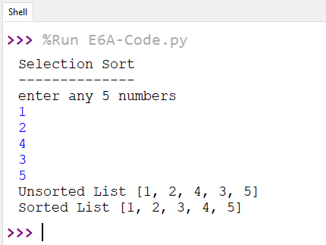

***Result:***

Thus the program to perform sorting in a list using selection sort algorithm was developed and tested successfully.